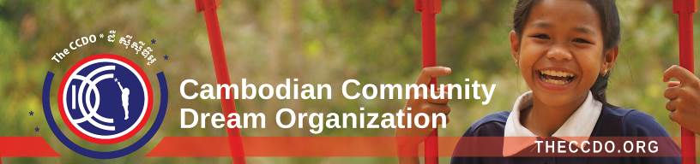

2 November 2024

TAP Initiative

California

[thetapinitiative@gmail.com](mailto:thetapinitiative@gmail.com)

Dear TAP Initiative,

Thank you for your generous donation of $4,000 in support of the Cambodian Community Dream Organization for Health in School Project as well as school supplies for TaPang School.

Your gift helps us achieve our mission of providing opportunities for children living in poverty in Cambodia to grow up healthy and educated by building clean-water wells and providing food, clothing, school supplies and support for teachers. Truly, with this gift, you are helping families in the poorest communities, saving lives and giving hundreds of children a chance to be happy, to be engaged in the world around them through learning, and to develop into successful adults.

Again, and on behalf of the children of Cambodia you have helped.

Best Regards,

Jenni Lipa

President

Cambodian Community Dream Organization.

The Cambodian Community Dream Organization is a 501(c) (3) nonprofit organization. Contributions to the Cambodian Community Dream Organization are tax deductible to the full extent permitted by law. No goods or services were provided in exchange for the above gift. www.theccdo.org